**Neural Network**

**Example-50 startups dataset**

'data.frame': 50 obs. of 5 variables:

$ R.D.Spend : num 165349 162598 153442 144372 142107 ...

$ Administration : num 136898 151378 101146 118672 91392 ...

$ Marketing.Spend: num 471784 443899 407935 383200 366168 ...

$ State : Factor w/ 3 levels "California","Florida",..: 3 1 2 3 2 3 1 2 3 1 ...

$ Profit : num 192262 191792 191050 182902 166188 ...

**One variable is factor and remaining all are numeric and our target variable is**

**Profit which is numeric and continues in nature.**

**Pairs Plot 🡺**

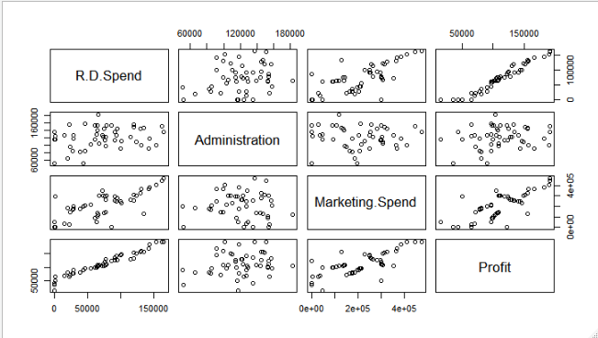

**From the above plot, R.D.Spend and Marketing.Spend are positively correlated with Profit and rest are showing week correlation among themselves with each other.**

**Correlation Plot 🡺**

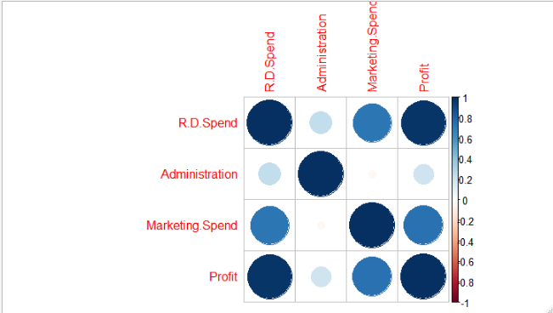

**Ignoring diagonal elements.**

**Box Plot 🡺**

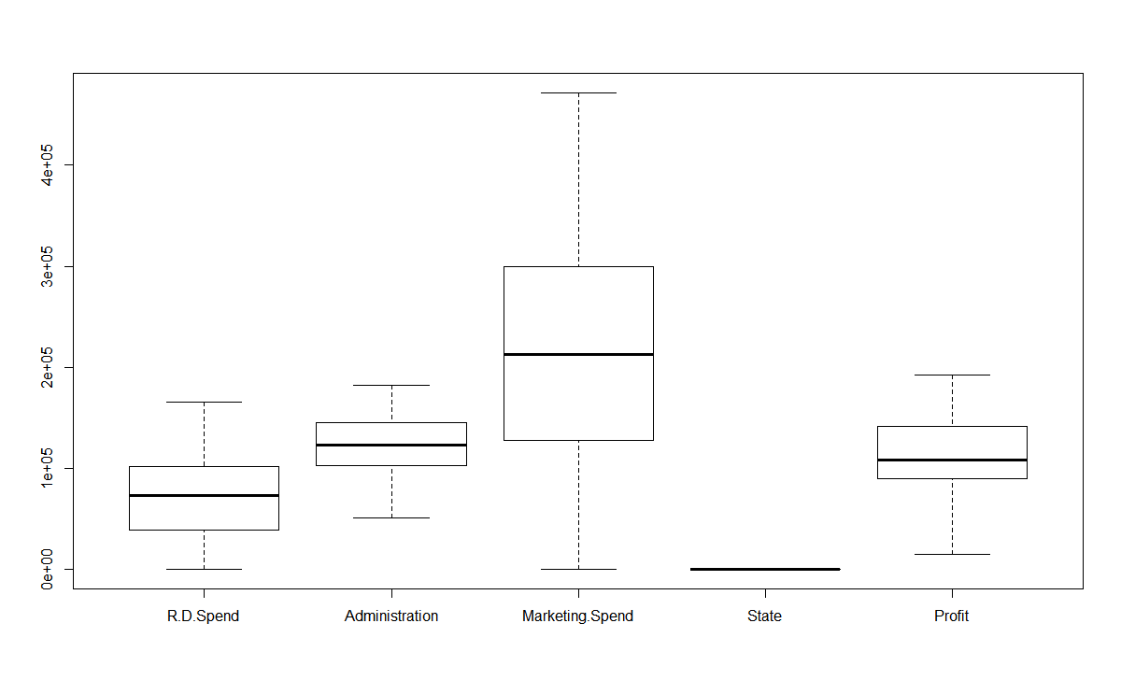

**From the above boxplot, there are no outliers in dataset.**

**Model-1 🡺**

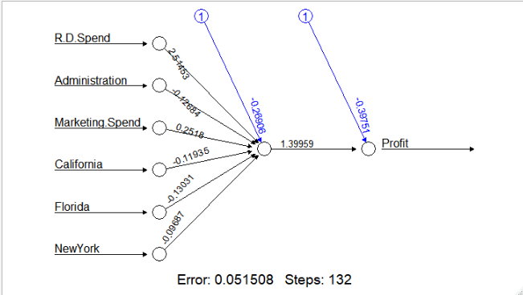

**In model-1 there are no hidden layer.**

**Accuracy 🡺0.9563**

**Accuracy is high due R.D.Spend because it is highly correlated with the profit.**

**Model-2 🡺**

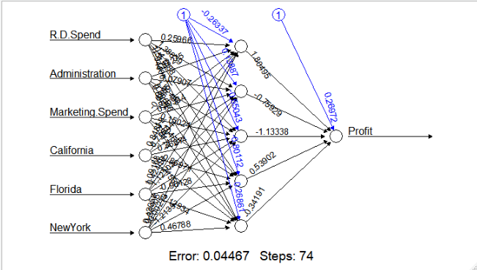

**In this model considered 5 hidden layers and accuracy improved slightly to 0.96**

**So, we will consider Model-2 as our final model because in this job is done only**

**in 74 steps while in Model-1 it takes 132 so my computational speed will**

**decrease.**